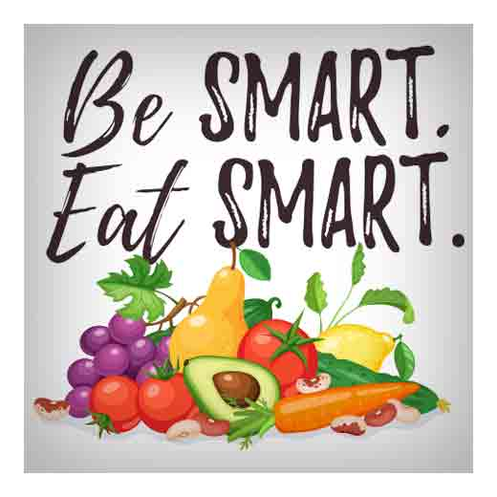**Raul Yzaguirre Schools for Success**

**Fresh Fruit and Vegetables Program**

**November, 2020**

|  |  |  |  |  |
| --- | --- | --- | --- | --- |
| Monday | Tuesday | Wednesday | Thursday | Friday |
| 2 | 3 | 4 | 5 | 6 |
|  | Pears - Ingredient - FineCooking**Fresh Pear** | **Pineapple/Grape Mix**  Image result for citrus mix | Image result for jicama sticksImage result for carrots,celery,jicama sticksImage result for carrots sticks**Celery/Carrots/Jicama** |  |
| 9 | 10 | 11 | 12 | 13 |
|  | **Kiwi Sliced**  [Kiwi Fruit - Early 'N' Fresh](https://www.google.com/url?sa=i&url=https://earlynfresh.com.au/shop/kiwi-fruit/&psig=AOvVaw33OXCInzH3Z7MWkvhH7YNi&ust=1599053036666000&source=images&cd=vfe&ved=0CAIQjRxqFwoTCKCbr_OGyOsCFQAAAAAdAAAAABAK) | **Fruit Mix**  [http://swiftproduce.com/yahoo_site_admin/assets/images/fruit-mix.145224624_std.jpg](http://www.google.com/url?sa=i&rct=j&q=fruit+mix&source=images&cd=&cad=rja&docid=gWptUd77pmqVqM&tbnid=btsh5IVdSIiD6M:&ved=0CAUQjRw&url=http://swiftproduce.com/for_restaurants__hospitals&ei=JlkWUoOxIMOZ2QXpgYHwDA&bvm=bv.51156542,d.b2I&psig=AFQjCNFEFLMj_8XfqL5UQ3ZJjHBQYVALdA&ust=1377282721528329) | **Sweet Potato Sticks**  [Image result for sweet potato](https://www.google.com/url?sa=i&rct=j&q=&esrc=s&source=images&cd=&cad=rja&uact=8&ved=2ahUKEwi7-YTk9OzcAhUEDKwKHdK1DnMQjRx6BAgBEAU&url=https://monadnockfood.coop/delightfully-healthy-say-sweet-potato-say-avocado/&psig=AOvVaw1nnPnoUPslw4JcnMx7FsAY&ust=1534348777485091) |  |
| 16 | 17 | 18 | 19 | 20 |
|  | Brazos Blackberry Plant - 2 Year Old - Buy Blackberry Plants**Blackberries** | **Squash Zucchini Sticks**  [Zucchini - Comprar en Estacion Vegetal](https://www.google.com/url?sa=i&url=https://www.estacionvegetal.com.ar/productos/zucchini/&psig=AOvVaw2aUhfvOqBnbHvWeE4ofkr4&ust=1599052953286000&source=images&cd=vfe&ved=0CAIQjRxqFwoTCLiNqcyGyOsCFQAAAAAdAAAAABAO) | **Kiwi/Orange/Pineapple**  Related imageImage result for pineappleImage result for kiwi fruit |  |
| 23 | 24 | 25 | 26 | 27 |
|  | Thanksgiving  Holiday | Thanksgiving  Holiday | Thanksgiving  Holiday |  |
| 30 |  |  |  |  |
|  |  |  |  |  |