ALGII.2A: Graph the Function, f(x) = $\sqrt[3]{x}$ and Analyze the Key Attributes such as Domain, Range, Intercepts, Symmetry, Maximum and Minimum.

A. Cubed Root Parent Function
- The equation of the cubic parent function is given by f(x) = $\sqrt[3]{x}$ and shown in the graph below.
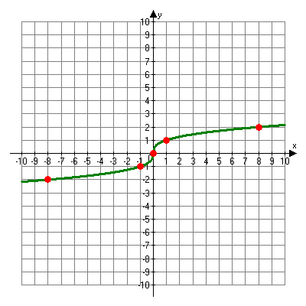
- The table below outlines the characteristics of the cubed root parent function.

Function | Domain/Range | Intercepts | Symmetries | Asymptotic Behavior | Maximum/Minimum
f(x) = $\sqrt[3]{x}$ | Domain:  x $∈R$  {x |x $∈R$}  (-$∞$, $∞$)  Range:  y $∈R$  {y |y $∈R$}  (-$∞$, $∞$) | x-intercept: 0  y-intercept: 0 | Rotational about the origin by 180⁰. | None | Maximum: None  Minimum: None

B. Analyzing Domain, Range and Intercepts and Symmetry of Cube Root
Functions

- Rotational symmetry – symmetry that occurs if a figure can be rotated less than 360⁰ around a central point and still looks the same as the original.

- Note: When graphing the cube root parent function, it is convenient to choose x-values that are perfect cubes.

Example 1: Graph the function f(x) = $\sqrt[3]{x}$ $-$ 2. Identify the domain, range, intercepts and symmetry.
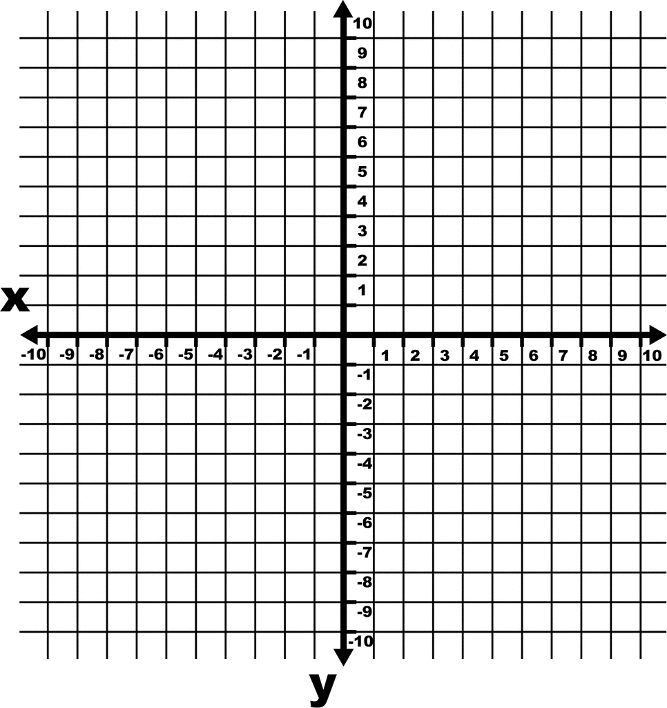

Example 2: Graph the function f(x) = $\sqrt[3]{x-1}$. Identify the domain, range, intercepts and symmetry.

Example 3: Graph the function f(x) = $\sqrt[3]{x+8}$. Identify the domain, range, intercepts and symmetry.

Example 4: Graph the function f(x) = $\sqrt[3]{x+2}$ $-$ 5. Identify the domain, range, intercepts and symmetry.

C. Maximum and Minimum Values of Cube Root Functions

- If function is always increasing, the minimum value will occur at the left-most endpoint of the interval.

- If function is always increasing, the minimum value will occur at the right-most endpoint of the interval.

- A table, graph or function equation can be used to find the maximum or minimum value of a cube root function over a given interval.

- If a table is used, you must first determine if the right and left endpoints are included.

- If they are included, since the cube root function is always increasing, the maximum occurs at the right endpoint and the minimum occurs at the left endpoint.

- If they are not included in the table, the graph or function equation maybe used to find the minimum and maximum.

- In these cases, the minimum and maximum values can be found by evaluating the function at the endpoints or by finding the highest and lowest points on the graph in the interval.

Example 5: Graph the function f(x) = $\sqrt[3]{x-2}$. . Find the maximum and minimum values over the given interval 4 $≤$ x $≤$ 7.

Example 6: Graph the function f(x) = $\sqrt[3]{x}$ + 1. Find the maximum and minimum values over the given interval [$-$8, 0].

Example 7: Graph the function f(x) = $\sqrt[3]{x+2}$. Find the maximum and minimum values over the given interval [$-$2, 6].

Example 8: Graph the function f(x) = $\sqrt[3]{2x}$ $-$ 2. Find the maximum and minimum values over the given interval [0, 4].

