Student Handout
California CareerZone
Quick Assessment Definitions
You will select three areas of interest from the California CareerZone Quick Assessment. To help you make your choices, review these definitions:
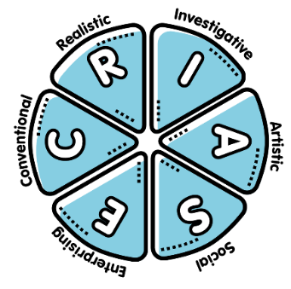
Artistic occupations frequently involve working with forms, designs, and patterns. They often require self-expression and the work can be done without following a clear set of rules.
Conventional occupations frequently involve following set procedures and routines. These occupations can include working with data and details more than with ideas. Usually there is a clear line of authority to follow.
Enterprising occupations frequently involve starting up and carrying out projects. These occupations can involve leading people and making many decisions. Sometimes they require risk taking and often deal with business.
Investigative occupations frequently involve working with ideas, and require an extensive amount of thinking. These occupations can involve searching for facts and figuring out problems mentally.
Realistic occupations frequently involve work activities that include practical, hands-on problems and solutions. They often deal with plants, animals, and real-world materials like wood, tools, and machinery. Many of the occupations require working outside, and do not involve a lot of paperwork or working closely with others.
Social occupations frequently involve working with, communicating with, and teaching people. These occupations often involve helping or providing service to others.

Student Handout

Access the Quick Assessment
Use these instructions to access the Quick Assessment:
- Go to the California CareerZone (https://www.cacareerzone.org/).
- Select “Discover Possibilities”.
- On the “Discover Possibilities” page, select “Quick Assessment”.
- On the “Quick Assessment” page, read the “Assess Yourself” instructions.
- Select the three that you feel best describe your interests.
- Now select the “View Results” button.
  - You will see a list of occupations that match the interests you chose.
- Select four occupations to complete the handout, What Skills Do I Need?

Student Handout

What Skills Do I Need?
Name: Date:
Use the occupational profile information from the California CareerZone* to complete this handout. In the Occupation column, list the occupations you selected from your results list.
Occupation title | Job-specific Skills  (“What They Do”) | Transferable Skills  (“Things They Need to be Able to do”)

*The California CareerZone URL is https://www.cacareerzone.org/.

Student Handout

What Skills Do I Need? page 2
For your 4 occupations, ask yourself what things are you doing now that’s helping you develop the job-specific and/or transferable skills each occupation needs. (Think about things like you’ve courses taken, clubs or teams you’ve joined, part-time jobs, internships, volunteering experiences.)
For your 4 occupations, what plans can you make to help you develop the
job-specific and transferable skills needed for each occupation?

